How many times have you heard something referred as sustainable?
Sustainability, this word is very wage.
The wage ness could be put into two groups. One is numbers which are measurable, one is focus.
How many times have you heard something referred to as sustainable?
It could be sustainable cotton, Sustainable cutlery, Sustainable farming, and sustainable coffee. Where the word sustainable added, that become popular.
When we focus on sustainability we focus only on one aspect. Take sustainable cotton, Which means it is organic cotton. That means no pesticides Means you are not putting chemicals in this environment. But organic means also low yields, more water. That means you need more resources in terms of land and water. These lead to higher associated carbon emission.
In Numbers when we say sustainable means it is more sustainable in comparison to others. So for example, if you take cappuccino, it generates 1 kg carbon, but if you take oatmeal cappuccino this yields .3 of that. This is good, but is it enough?

So what is sustainability, it is so fluffy, at present sustainability is used for anything or everything. When a word means everything, it means nothing.

Throwing away the word sustainability means that we purchase things which we feel are sustainable but in fact they are not. Because it is just a comparison with something else. This leads to misleading and confusion around what is sustainable. Sustainability policies which are not good enough are number problems or misdirected, that is the focus problem.
One of the closest definitions come across about sustainability is meeting our needs and compromising the ability of future generations to meet their needs.

This could be a good start but what do we need, do I need new clothes, a new iPhone or a new car?
It will be a shame that we are not able to come up with a definition of what is sustainability.
It is difficult to define something which has so many aspects of it and it could be part of everything.
Therefore, then we change it from sustainability to absolute sustainability.
What is absolute sustainability? Sometimes when we add a qualifier, the qualifier can help to dig out the hidden definition.
Take the word sustainable, soothing which is able to sustain itself. Something that will sustain it in the future. Why is the future important? Who has kids and family members who are younger than them? Because it is about them. If you love them, you care for them, right? Gurudev sabko pyar karte the, unke liye sara jag unka Parivar tha. Isliye unko sab ke liye soncana tha. Now the problem is not just able me it is about all those people for who I care and their generations to come.

So, to achieve sustainability we need to know what it looks like. So, lets define absolute sustainability together.
Let build on the notion that when we talk about sustainability it is able to sustain itself in future with putting strain on planet. But how do we know whether it can or cannot?
We determine how much something is allowed to impact the earth and then do the comparison how much does it impacts the earth. These are two numbers we can compare solving the numbers problem. Then we repeat the process to check different aspects of sustainability not just the climate change, but water, earth, forest, animal life, air etc. That will solve the focus problem because we have widened to multiple aspects and its impact on them.

Going through this actually we can answer the question whether something is sustainable in absolute term or not? Yes or no.
The idea that come down to a definition, that if we live with the given allowance which impacts in numbers is 0 and the different aspects which are affected and used what is allowance for us.
Based on this We can propose a definition which is coined by Gurudev in its Sadhana tava always. Something is sustainable means it stays in allowance given to each person. Reducing air pollution, stopping people from dying in is not sacrifices.
Sticking to your share you must stick must to your share. This is not the most inspiring thing anyone wants to hear. Some one has to become default. Opportunity to have a clean fresh air for breathing for every one clean abandon energy for every one.
Now the question how big my share is? Thinks about a cake.
Size of the cake
Who wants to share the cake.
How to divide the cake so every one gets their share.
Now think this cake is your earth. Share its water., air and land.
First question how big is the cake how big the pool or resources we have to share.
Who wants to share it, we all know who wants to share.
Some one worked hard and made the pools availability called the planetary boundary framework.it gives a number on how much we can strain our planets before we reach a disaster. The green area is where we should be with in the limits. And red where we already exceeded the limit. It tells how much carbon dioxide we emit into the planned before we reach a unacceptable and catastrophic climate change. How much fresh water can we use till we do not have enough? So, this answers our first question. How much bigger room do we have in those 9 focus areas.
Who wants to share the cake? Us and future generations.
The third question where it becomes tricky. Interdisciplinary. Concept like Sadhna. Here science meets philosophy and makes a mixed drink, which we all should drink.

So here we have to take knowledge from Gurudev literature and turn them into measurable Sankalps. Which allows us to calculate an exact answer, with this Practice is absolute sustainable or not? Also, in absolute terms. If it is no than how far we are from making it yes. This is pretty revolutionary. Because you all know that something is sustainable or not is a scientific question with two answers yes or no. So, be critical when you see something as sustainable, is this cotton is sustainable or not? Is this qualifying the test of absolute sustainability? We have started designing, products, services and even the policies with absolute sustainability. This forces us to be really radical, because better is not enough. As humans we have done incredible things. We need to know what the goal is. The goal is absolute sustainability. Can we do it yes, absolutely? Thanks.

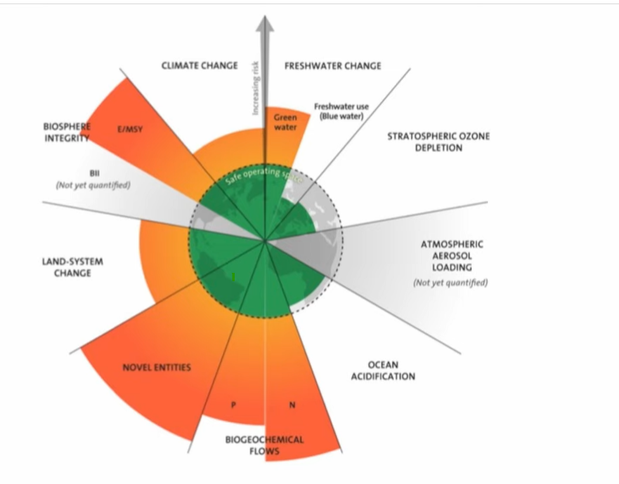

.

The conflict between man and man is not because of poverty and shortage, but because of the problem of ‘Mine’ and ‘Yours’. Everyone likes to have his own benefit, own prosperity and own welfare, but does not have the same feeling for other. Except for ‘self’ the person is not worried about the loss, insult or even death of another person. On the contrary, each one tries to take the maximum benefit from another person. There is a solution to this world wide problem. The solution lies in removing the heart from petty feelings of mine and yours and joining it with the whole universe. This maxim of co-existence is the first step in the practical path. Live or let live. Everyone must eat his bread out of honest income. The second maxim is:” I must contribute something towards the livelihood of other”.

Sustainability is an opportunity not a sacrifice.
Are we the last generation or first sustainable one?
Looking at the warning signs like water is diminishing, pollution is increasing, forests are being destroyed, temperature in increasing, we feel we are the last generation. The survey result.
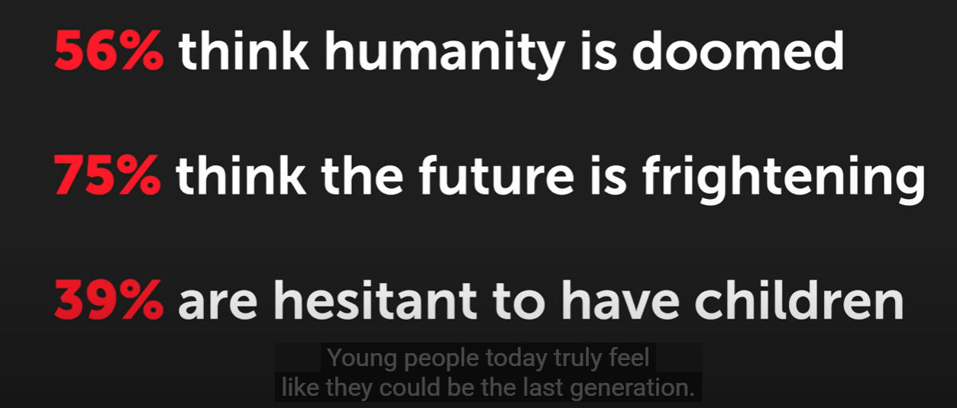

I also thought we are doomed. But then I started looking at data as where pollution figures are going, where resources are being used, what alternatives we have found. The progress we have made make we believe we can be the first generation to be sustainable.
Ancestors lived a sustainable life because the population was tiny. The population was tiny because half of children die before reaching puberty. This is not sustainability.
A good life for everyone + opportunity for future generation and other species.
If we fail on any half, we fail to be sustainable. We have done a good progress in first half, but that comes with a cost.
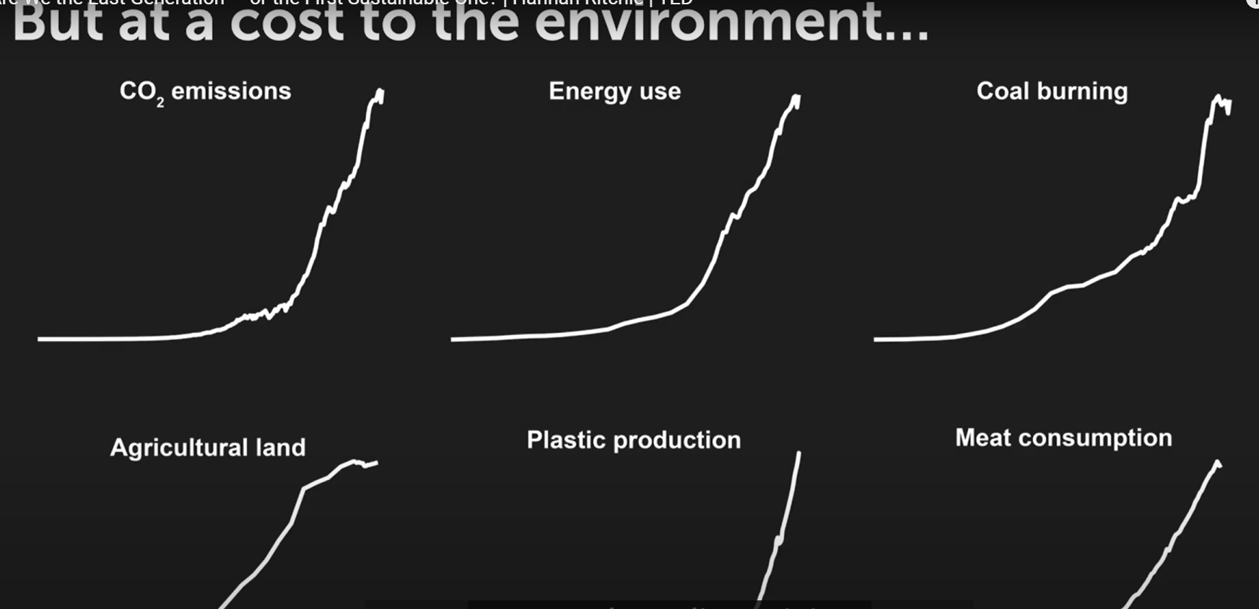
But now with technology things are reversing. Electricity comes form sun, wind instead of coal. The GDP is increasing , so the life of people. Deforestation is not only declined but forestation projects are making a + growth also. Crops yields are growing by using a small piece of land in comparison to old days.

What we need to do to become first generation.
- Affordable and Low carbon technology has to become default.
- We must be cautious about building this together. Learn about and talk about it without being Harras or preachy.

We need to see data to inspire, we see problem and we see solutions are in place, but is those are enough?
Relentless work done by activist, engineers, environmentalist, data scientist, entrepreneurs, communicators, awaken people are doing it. They are making the world a better place. They have bought us here and we have to take it from here. We have to make bigger and better impact and faster also. This is our opportunity to make the world a better place take it.

https://pippit.capcut.com/.
.

Relatable Examples
- Fast Fashion: Buying super cheap clothes that wear out fast creates waste. Sustainable choice? Buy better quality or thrift.
- Plastic Bottles: One bottle used for 10 minutes lasts 100s of years in the ocean.
- Energy Use: Leaving lights on when not needed means more fossil fuels burned = more pollution = worse climate.

🧠 Analogy
"Think of Earth like a phone battery. If you keep using it without charging it or protecting it, it dies. Sustainability is like using power-saving mode and charging it wisely."

✅ What They Can Do
- Recycle and reuse stuff
- Buy less, buy smart
- Eat less meat sometimes
- Walk or bike when possible
- Call out waste when they see it
- Use social media to spread awareness

🎬 Optional Add-on
You can show short, engaging videos (like from Kurzgesagt or Our Changing Climate on YouTube) to spark interest.
Want this explanation turned into a short presentation, TikTok script, or classroom activity?

- Sustainability = Environmental + Social + Economic responsibility
- Why measure?
- Track progress
- Report performance
- Drive accountability

What They Can Do
- Recycle and reuse stuff
- Buy less, buy smart
- Eat less meat sometimes
- Walk or bike when possible
- Call out waste when they see it
- Use social media to spread awareness

You can have everything you want if you help enough other people get what they want.

